3. Scenario
You have been contracted by a small business called
You have been contracted by a small business called TechBridge Solutions to design their cloud network infrastructure. The business requires a virtual network that separates public-facing resources from internal back-end systems. Your design must account for at least two distinct network segments.

You are free to determine the specifics of the design — address ranges, number of subnets, and security rules — but your choices must be documented and justified.

4. Tasks and Mark Allocation
Task 1 and 2:
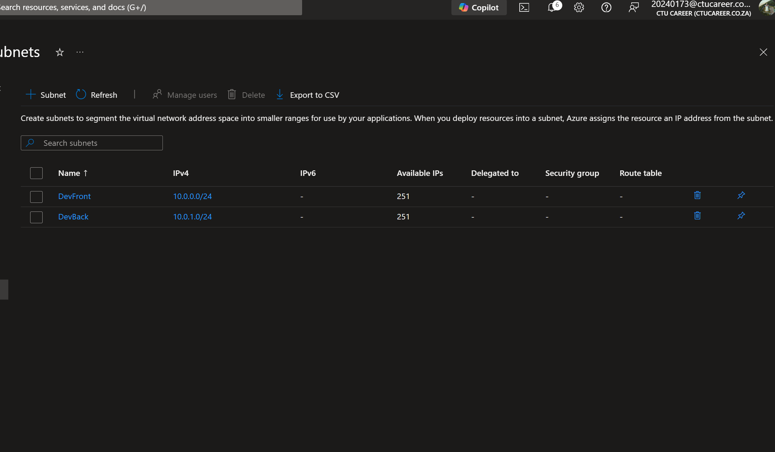
I’ve selected the Class A private address as it contains many addresses that can be taken advantage of if the network expands, I’ve also created 2 subnets one for internal back-end systems and one for External public facing resources. I’ve also ensures that the External has more usable hosts to accommodate the additional traffic it needs to be able to handle.
Task 3
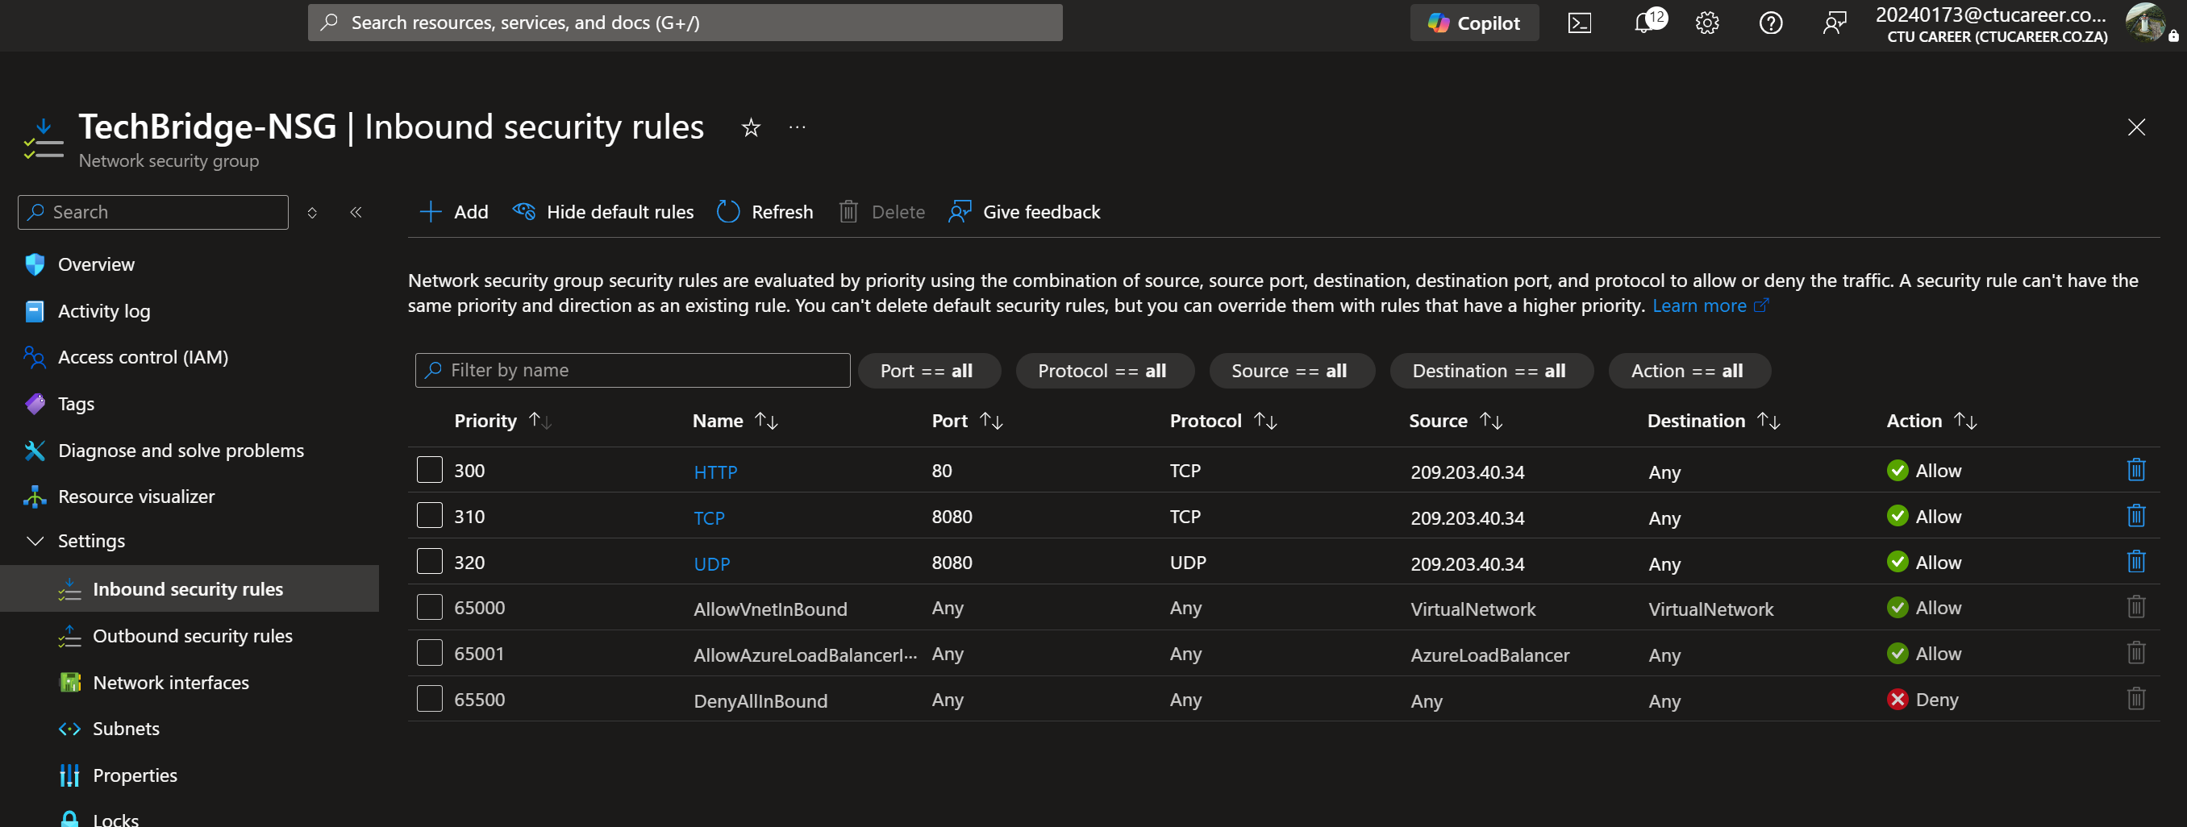
These three inbound rules are for icoming internet, administrative usage and emergency entrance to the network

